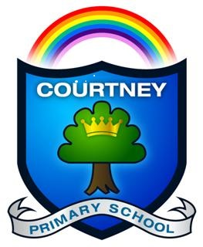 | Headteacher: Miss Georgina Scott  Nurture, Inspire, Flourish. | 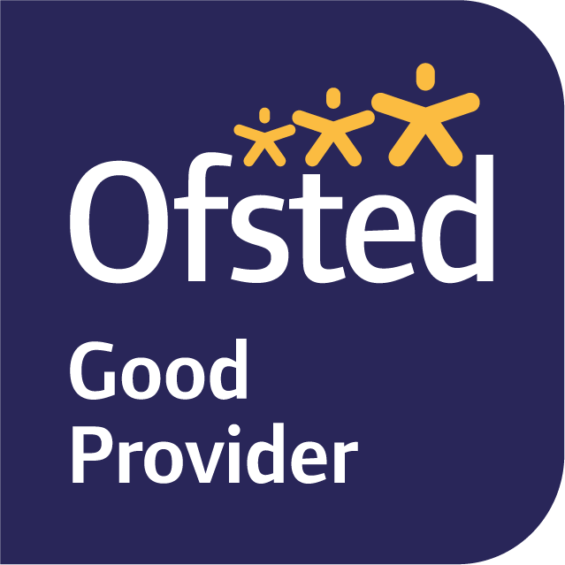
Courtney Primary School , Courtney Road, Kingswood, Bristol, BS15 9RD Email:office@courtneyps.org.uk
www.courtneyprimaryschool.co.uk Tel: 01454 866670

13th September 2021
Dear Parents,

Re: Year 6 and Year 5 Day Visits to Sevington Victorian School on Thursday 14th and Friday 15th October 2021 (respectively)

On Thursday 14th (Year 6) and Friday 15th (Year 5) October, the children will be visiting Sevington Victorian School to experience life as a Victorian child. This visit will help to embed learning earlier in the term about what life was like for Victorian children, particularly in relation to their school life experiences. We will leave school at 9:00am and return at approximately 3:00pm. To fully immerse ourselves during the day, we are asking every child to enter into the Victorian spirit! Please read the guidelines below:

Clothing
Your child will need to wear a Victorian outfit for the day. Sevington is a Victorian building and can feel very cold by modern standards so please wear something warm under the costume.

Girls could wear appropriate costume or woollen shawl over long sleeved blouse and mid length skirt, dark tights and sturdy shoes or boots - not trainers or sandals. Overlong skirts are not authentic, they are also difficult to walk and play in. Long hair was usually gathered from sides and fastened on top with back hanging loose. Mop caps and pinafores can be worn.

Boys could wear appropriate costume or cut off below knee length trousers, long dark plain trousers, long sleeved shirt, a waistcoat, buttoned jacket or plain dark jumper. Caps must be worn.
Sturdy shoes or boots - not trainers or sandals.

Depending on the weather please also provide your child with a waterproof coat. If you need any support in creating an outfit, please speak to a member of the Y5/6 team in the first few weeks of term.

Food
Your child will also need a Victorian lunch. A hunk of bread and cheese with an apple would be simple and authentic. Other suitable items include raw carrot, cold boiled or jacket potatoes, pasties, a pastry pie. Gingerbread, shortbread, or a slice of cake could be included as a treat. Children should bring their food in a named paper bag or wrapped in greaseproof paper or a tea towel. No other food is necessary, especially not sweets or snacks. Remember that oranges, bananas, yoghurts etc are not appropriate. The children do not need to bring any drinks as they will be given water by the school.

If your child is entitled to a Free School Meal and you would like a school packed lunch, then please indicate on the reply slip below.

In order to cover the cost of the visit, including the coach fare, please could you send the amount of £13.40 which needs to be paid by 24th September and can be paid via Arbor or by cash into the school office (preferably in a sealed and clearly labelled envelope). If we don’t receive sufficient payments, then the visit may not go ahead.

If during the visit your child will require additional medication to that which they already have in school, whether it is prescribed or non-prescribed medication such as travel sickness pills, you will need to complete a Day Visit Request to Administer Medication Form which can be obtained from the office staff.

Please complete the consent form below and return it to school by Friday 24th September.
Yours sincerely,

The Year 5 and 6 Team……………………………………………………………………………………………………………………………………………

Year 5/6 Visit to Sevington Victorian School on Thursday 14th October/Friday 15th October 2021

I give consent for my child ______________________________ to take part in the visit. | Yes/No
I enclose the payment of ______________________.  I will pay online via Arbor | Yes/No  Yes/No
My child has Free School Meals and I would like them to have a packed lunch prepared by the school. | Yes/No

Signed_______________________________________________________ Parent/Carer Date____________________________

