COVID update
Key changes to guidance
There is no longer a legal requirement for people with COVID-19 to isolate
BUT public health guidance STILL advises people to stay home for 10 days (or until have 2 negative
LFDs on consecutive days from day 5)
There is no longer a legal requirement to tell employers when required to self-isolate
Routine contact tracing (provided by NHS Test and Trace) has now ended, and close contacts will no longer be required to self-isolate or advised to take daily LFD tests.
People with COVID-19 will be encouraged to inform their close contacts, household and overnight contacts to take additional precautions for 10 days
Twice weekly routine asymptomatic testing is no longer recommended in mainstream EYFS settings.

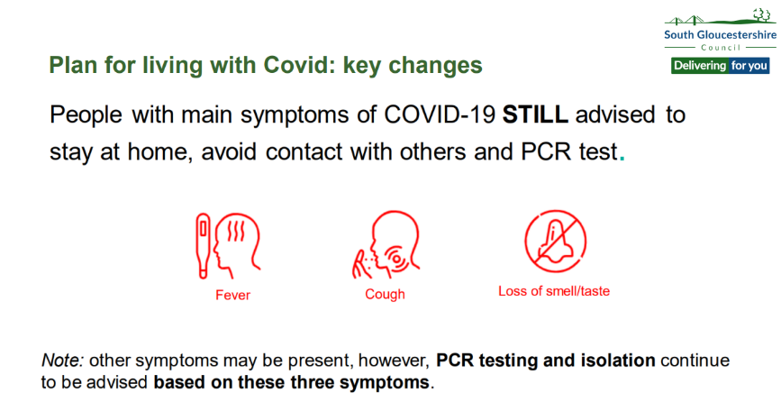
Staying at home if unwell
• Children who are unwell should not attend the setting and should remain at home until their acute symptoms resolve. This has always been the case.
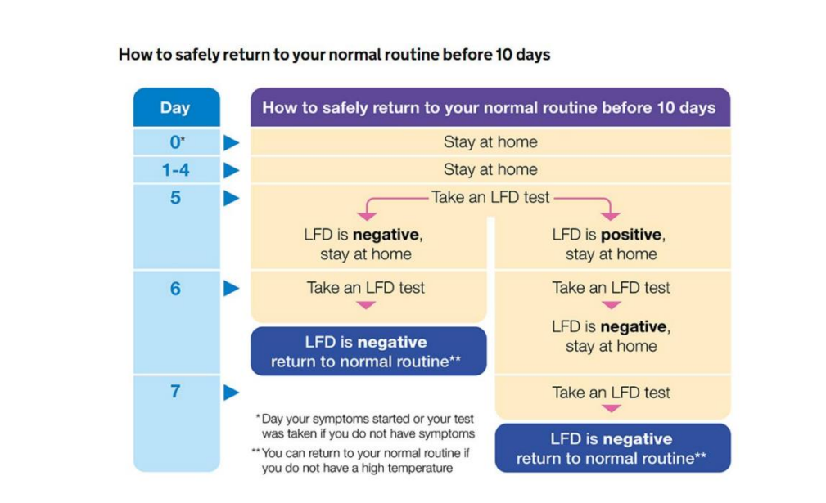
• IF these symptoms develop into cough, temperature, changes to taste and smell, advice remains to isolate and PCR test for COVID-19
• IF test negative to COVID-19, return to setting once well (acute symptoms resolved)
• IF test positive to COVID-19, follow advice to isolate, return once well and: In line with COVID-19: COVID-19: people with COVID-19 and their contacts - GOV.UK (www.gov.uk)
• Examples of acute symptoms with which children should not attend school/nursery include fever, muscle aches, hacking cough.
• Examples of symptoms with which children could attend school/ nursery include persistent runny nose, irritable cough (that is not Covid, or that remains after advised isolation period)
Additional measures
As a school, we will consider additional measures when any of the following thresholds have been met:
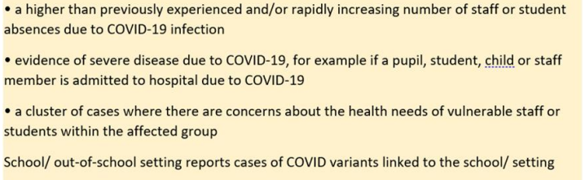
Additional measures may include:
• Warn and inform information to setting, or group within the setting.
• Measures to promote social distancing, reduce crowding or inter-group mixing
• Measures to reduce mixing of staff
• Temporary limits on visits in and out of setting (e.g. performances, educational visits)
• Temporary reintroduction of face coverings in communal areas and/or classrooms

Confirmed COVID-19 cases
If we as a school have confirmed COVID-19 cases, we will be refusing them access to school to protect other pupils and staff following the operational guidance below.
“In most cases, parents and carers will agree that a pupil with the key symptoms of COVID19 should not attend the school, given the potential risk to others. If a parent or carer insists on a pupil attending your school where they have a confirmed or suspected case of COVID-19, you can take the decision to refuse the pupil if, in your reasonable judgement, it is necessary to protect other pupils and staff from possible infection with COVID-19”.
Schools COVID-19 operational guidance (publishing.service.gov.uk)
What parents and carers need to know about early years providers, schools and colleges - GOV.UK
'Reasonable judgement' means that we may refuse the child/staff member to attend if they test positive, however this is on the basis that it IS reasonable to assume that a person with a positive test is infectious to others in the period after and the main symptoms are considered sufficiently discriminatory to suspect Covid, and thus infectiousness to others.
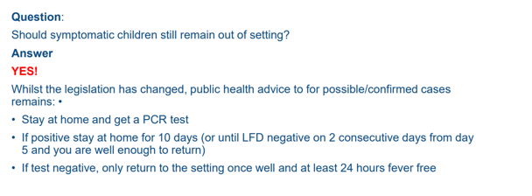
Most children and young people with COVID-19 experience a mild illness or do not have any symptoms at all. Children who have symptoms of COVID-19 are more likely to pass the virus onto others than those who do not. At this point they can safely return to their normal routine (and come into the setting) as long as they do not have a temperature. They will be advised to avoid meeting people at higher risk of becoming seriously unwell from COVID-19 for 10 days.

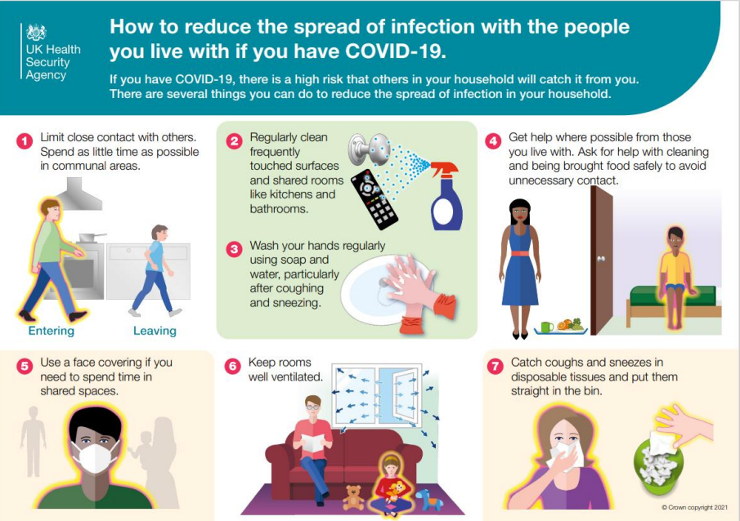
Supporting families Community
Resilience fund
Self-isolation payments for those who have tested positive for Covid-19 have now ended, but if you need to take time off work and your income will be reduced as a result, our Community Resilience Fund is here to help you. Community resilience fund | BETA - South Gloucestershire Council (southglos.gov.uk)

We appreciate your continued support during this changing landscape.
If you have any questions, please get in contact.
Kind Regards

Ms G Scott
Headteacher

